TRANSFORMATIONS

Instructions:
Please share your answers filled inline in the word document. Submit code files wherever applicable.

Please ensure you update all the details:
Name: ___G RUPAK______________________
Batch Id: ___07/05____________________
Topic: Data Pre-Processing

Problem Statement:
Everything will revolve around the data in Analytics world. Proper data will help you to make useful predictions which improve your business. Sometimes the usage of original data as it is does not help to have accurate solutions. It is needed to convert the data from one form to another form to have better predictions. Explore on various techniques to transform the data for better model performance. you can go through this link:
https://360digitmg.com/mindmap-data-science
- Prepare the dataset by performing the preprocessing techniques, to have the data which improve model performance.

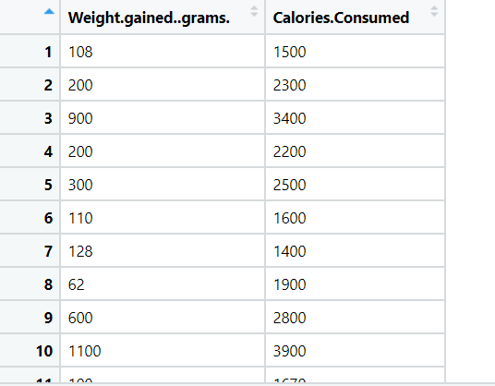
import pandas
import matplotlib.pyplot as plt
# import the data as a pandas dataframe object
df = pandas.read_csv("D:/Data Science/ASSIGNMENT/Assignments 3/DataSets/calories_consumed.csv")
#visual inspect the distribution of our variables
df.hist(grid=False,
figsize=(10, 6),
bins=30)
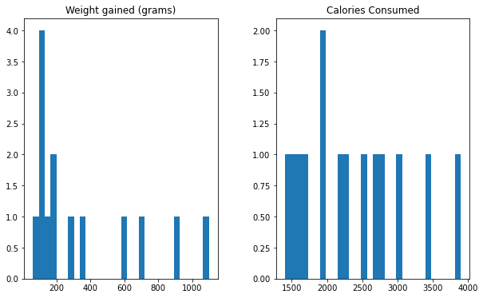

In the above histogram shows left skewed

#measure of skewness and kurtosis
df.agg(['skew', 'kurtosis']).transpose()
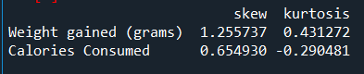
from scipy.stats import boxcox
# Box-Cox Transformation in Python
df.insert(len(df.columns), 'A_Boxcox',
boxcox(df.iloc[:, 0])[0])
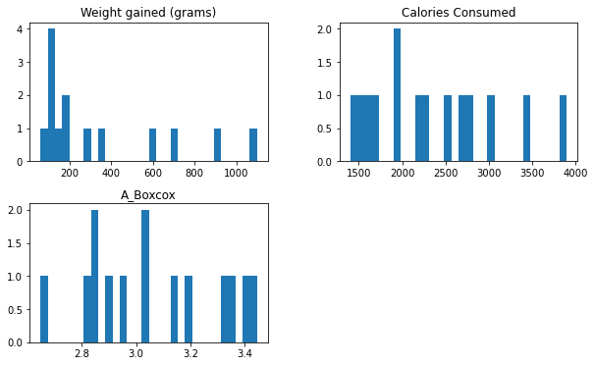

Hints:
For each assignment, the solution should be submitted in the below format
- Work on each feature to create a data dictionary as displayed in the image displayed below: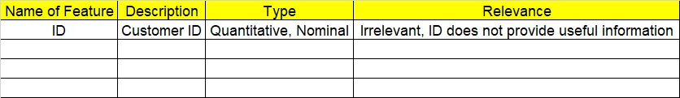
- Hint: Refer to calories_consumed.csv dataset
- Research and perform all possible steps for obtaining solution
- All the codes (executable programs) should execute without errors
- Code modularization should be followed
- Each line of code should have comments explaining the logic and why you are using that function

Grading Guidelines:
Note: 1. An Assignment submission is considered complete only when successful executable code(s), and documentation explaining the applied solution and results are provided. Failing to submit either of them will be considered an invalid submission and will not be considered for evaluation.
2. Assignments submitted after the deadline date will affect your grades.

Grading:
Ans | Date |  |  | Ans | Date
Correct | On time | A | 100
80% & above | On time | B | 85 | Correct | Late
50% & above | On time | C | 75 | 80% & above | Late
50% & below | On time | D | 65 | 50% & above | Late
 |  | E | 55 | 50% & below
Copied/No Submission |  | F | 45

- Grade A: (>= 90): When all assignments are submitted on or before the given deadline date
- Grade B: (>= 80 and < 90):
  - When assignments are submitted on time but less than 80% of questions asked in assignments are completed. (or)
  - All assignments were submitted, however, after the given deadline

- Grade C: (>= 70 and < 80):
  - When assignments are submitted on time but less than 50% of questions asked in assignments are completed. (or)
  - Less than 80% of questions asked in assignments are submitted after the deadline

- Grade D: (>= 60 and < 70): Assignments submitted after the Deadline and with 50% or less of questions

- Grade E: (>= 50 and < 60):
  - Less than 30% of questions asked in the assignments are submitted after the deadline (OR)
  - Less than 30% of questions asked in the assignments are submitted before deadline

- Grade F: (< 50): Copied submission or No submission

